Annual Implementation Plan - 2026

Yea Primary School (0699)

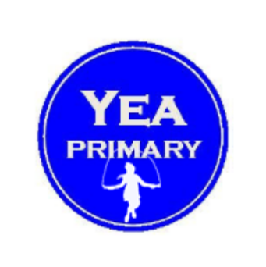
Submitted for review by Craig Irvine (School Principal) on 04 February, 2026 at 11:08 PM
Endorsed by Rhonda Cole (Senior Education Improvement Leader) on 06 February, 2026 at 08:03 PM

Select annual goals and KIS

Four-year strategic goals | Is this selected for focus this year? | Four-year strategic targets | Key Improvement Strategies | Is this KIS selected for focus this year?
Improve student achievement and growth in literacy and numeracy. | Yes | By 2025 the three-year rolling average for the percentage of students in the top two NAPLAN bands will increase for:  Year 3:  - Reading from 47% in 2019-21 to 60%  - Writing from 58% in 2019-21 to 60%  - Numeracy from 36% in 2019-21 to 45%  Year 5:  - Reading from 19% in 2019-21 to 40%  - Writing from 7% in 2019-21 to 25%  - Numeracy from 18% in 2019-21 to 30% | Build teacher capability to consistently implement the agreed instructional models in literacy and numeracy. | No
 | Yes | By 2025 the three-year rolling average for the percentage of students meeting or above NAPLAN benchmark growth will increase for:  - Reading from 62% in 2019-21 to 75%  - Writing from 70% in 2019-21 to 75%  - Numeracy from 55% in 2019-21 to 75% | Develop effective systems and processes to use data and evidence to differentiate instruction and monitor impact on learning growth. | No
 | Yes | By 2025 the percentage of students reported as achieving at, or above age expected growth by teacher judgement against the Victoria Curriculum will increase for:  - Reading and Viewing from 62% in 2021 to 85%  - Writing from 60% in 2021 to 85%  - Number and Algebra from 78% in 2021 to 85% | Implement effective professional learning community practices. | Yes
Enhance student engagement and wellbeing outcomes. | Yes | By 2025 the percentage of positive responses on the Attitudes to School Survey will increase for:  - Stimulated learning from 76% in 2021 to 80%  - Effective classroom behaviour from 68% in 2021 to 80%  - Managing bullying from 69% in 2021 to 80%  - Sense of connectedness from 73% in 2021 to 80%. | Implement and embed the school wide positive behaviour support (SWPBS) framework. | No
Enhance student engagement and wellbeing outcomes. | Yes | By 2025 the percentage of positive responses on the School Staff Survey will increase for:  - Collective efficacy from 59% in 2020 to 80%  - Teacher collaboration from 40% in 2020 to 80%  - Instructional leadership from 48% in 2020 to 80%. | Develop inclusive practices to support engagement. | Yes
Enhance student engagement and wellbeing outcomes. | Yes | By 2025 the percentage of positive responses on the Parent Opinion Survey will increase for not experiencing bullying from 64% in 2021 to 72%. | Develop student voice and agency in learning. | No
Enhance student engagement and wellbeing outcomes. | Yes | By 2025 attendance will improve such that:  - average days absence will decrease from xx in 2022 to 13.5 days  - the percentage of students with more than 20 days will decrease from xx% in 2022 to 20% (To be finalised)

